ASSIGNMENT 2B

ARFAZ HOSSAIN

V00984826

PLEASE TURN OVER

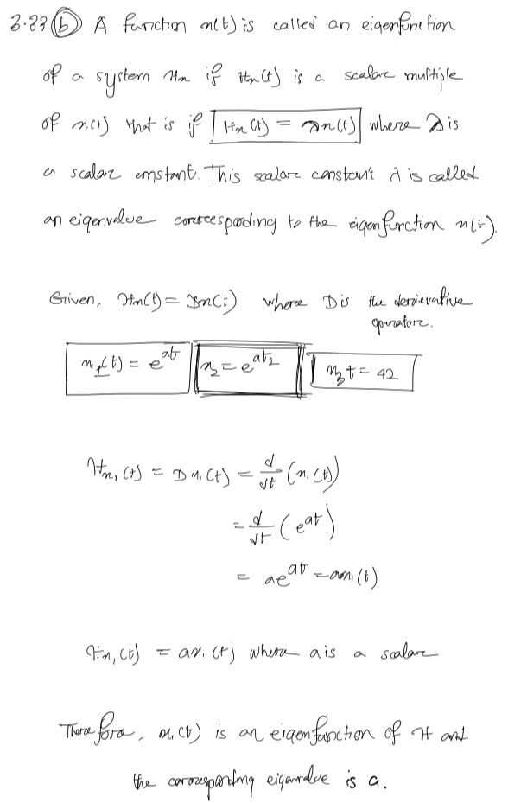

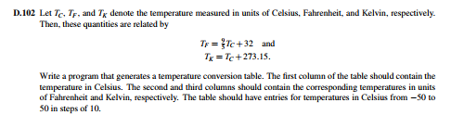

(A)

(B) ~ (C) ~

END OF ASSIGNMENT 2B